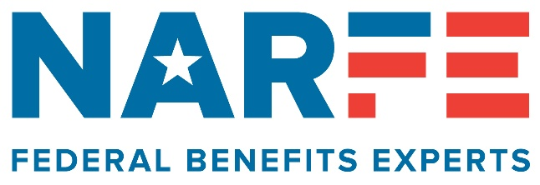
CHAPTER MEETINGS/PROGRAMS
2026 Chapter 1192 Officers & Board Members
President, Mary Alice Binder 509.378.2494
Vice President, Vacant
Secretary, Vacant
Treasurer, Liz Bowers 509.430.1836
Alzheimer’s, Larry Williams 509.783.8554
Caller Coordinator, John Wetterling 509.948.9894
Hospitality/Zoom, Nancy Crosby 509.735.3288
Legislative, Mary Alice Binder 509.378.2494
Membership, Johanna Caylor 509.375.0739
NARFE-PAC, Mary Alice Binder 509.378.2494
Newsletter, Mary Alice Binder 509.378.2494
PR/Service Officer, Mary Alice Binder 509.378.2494
Sunshine, Faye Vlieger 509.961.1095
Webmaster, Larry Williams 509.783.8554
TRI-CITIES CHAPTER 1192
NARFE NEWS
National Active and Retired Federal Employees Association
Advocates for Current and Retired Federal Employees
NARFE: www.narfe.org Washington Federation: www.narfe.org/wa/ Tri-Cities: www.narfe1192.org

REMINDER: FEHB/PSHB Programs Open Season – November 9 thru December 14. See page 2.

Meetings: 1st Wednesdays, except July/August
11:30 a.m., CG Public House & Catering, Kennewick
Lunch: $25; RESERVATIONS REQUIRED
(Vegetarian & gluten-free meals available, if ordered ahead)
Avoid a charge! Cancel reservations you can’t keep!
(Board meetings are virtual; contact Nancy Crosby for
Zoom link. Next meeting: Monday, December 7, 1:30 p.m.)

Upcoming Chapter Meetings


November 4 – Ari Laguna Antu, SHIBA regional training consultant, to provide a healthcare coverage update. Statewide Health Insurance Benefits Advisors, Office of the Insurance Commissioner, provide free, unbiased info about healthcare coverage, including Medicare.
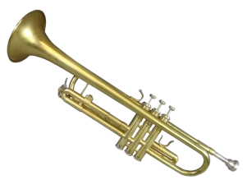
Menu: turkey, stuffing, mashed potatoes, gravy, corn, cranberry sauce, rolls, dessert
November 1, Daylight Saving Time ends. Fall back!
December 2 – Jeff Peterson and his trumpet
return with a holiday music program!
Menu: meatloaf, mashed potatoes, gravy,
veggies, rolls, salad, dessert
For Chapter & National-Only Members
outside the Tri-Cities area!
MOST WELCOME to attend a chapter meeting, including lunch! RESERVATION NEEDED. Call Nancy Crosby or John Wetterling by noon, Sunday, prior to a chapter meeting. (Phone numbers above!)

November – December, Volume 2026, Issue 6


President – Mary Binder
Fall is definitely here. Speaking for
myself, I really, REALLY enjoy this
season – the cooler days, gorgeous
colors, clearer air, and the holidays.
What a truly special time of year.

This is also the busiest “NARFE” time of year for outreach events. As I worked on this newsletter, there has been a NARFE presence at 6 events in Eastern Washington with 5 remaining – recaps and updates in the following pages! A very, VERY sincere thank you to every volunteer who helped with events far and near, including set up and take down, talking to individuals who stopped at the NARFE table, handing out our Jelly Belly bean treat bags, taking names and questions, etc.


Voting and elections … hard to know where to start in this area, but some things I do know – it is time consuming to be engaged: to listen, to learn, to question; to believe in voting and knowing votes count. Besides our NARFE national and federation (state) elections, we are closing in on national, state and local elections. Results will bring satisfaction and relief to some; for others, it will be frustration and disbelief. May we appreciate the opportunity we have to be involved, respect differences and continue to stay engaged and vote.

Speaking of which, at this time next year, we will be holding chapter officer elections. In the interim, however, our vice president and secretary positions remain vacant! Volunteering to serve in those vacancies would certainly help in 2027, and most importantly, be
a way to “test the waters” so to speak. Please consider doing so. Contact me if you have questions and/or want to know more.

As 2026 ends, thank you for your support! All the best!

Hospitality Coordinator – Nancy Crosby
… for Members to Continue Pondering!
2026 is ending soon, but if there is something you haven’t done, or done for a while with Chapter 1192, there is still time! Suggestions:
- Attend a chapter meeting if you’ve never been, or if it has been a while
- Bring a guest/prospective member to a meeting
- Recruit a new member, or get a current or dropped member to renew
- Attend a virtual board meeting
- Volunteer to coordinate a speaker/program for a chapter meeting, or a chapter group event
- Donate to/increase a donation to the NARFE Alzheimer’s Research Fund, or to NARFE-PAC and/or become a PAC sustainer
- Contact an elected official
- Volunteer to help at an outreach event
- Explore the chapter, WSF or NARFE websites to become more familiar with them; much good info
- Sign up for electronic NARFE updates
Thank you to those who have already responded. More ideas? Questions? Contact Mary Binder!

The chapter’s holiday menus for our November and December meetings are set. (See page 1) Last year we had wine as a special holiday treat for members wanting to participate.
With positive feedback, we are doing so again!

Service Officer – Mary Binder (Acting)
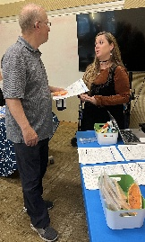
Health benefits open season is here, November 9 to December 14. Chapter members Nancy Crosby and Ellen LeVee coordinated a chapter-hosted health fair at the Richland Public Library, Wednesday, October 21, 5 to 6:30 p.m. They worked to ensure area NARFE members, and other current and retired federal employees received information about the event, with a special emphasis on getting details to area postmasters.

There were reps from BC/BS and Kaiser at the event. They provided information, talked with and answered questions for about 20 attendees, including several NARFE chapter members, visiting their tables. (Photo, left, chapter member Randy Grekowicz talking with Kaiser Rep Tiffany Todd.) [To note – GEHA information was available but a rep could not attend. For members with GEHA questions, and/or needing information, contact Jenna Crawford, GEHA west coast sales regional manager, at: 816.434.2273.]

We strongly recommend reviewing 2027 material early in open season. Helpful resources: directly through a provider; online; NARFE Magazine; having material sent to you. Questions? Contact Nancy, 509.735.3288 or Ellen, 509. 438.4284.

REMINDER about Medicare Part B!
Several federal plans offer premium reimbursements! Check your plan!

WISeR Pilot Program – The pilot program is scheduled for January 1, 2026 to December 31, 2031. The Wasteful and Inappropriate Service Reduction Model includes Washington and 5 other states: New Jersey; Ohio; Oklahoma; Texas, Arizona. Info at Centers for Medicare/Medicaid Services website: CMS.gov/priorities/innovation/innovation-models/wiser.
(Website last update, October 19, at newsletter press time.)

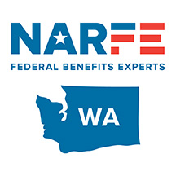
WSF Eastern Washington VP – Mary Binder This is my last article as the WSF Eastern Washington District VP. I have served the federation and the district’s members in this position for now 10 years. Thank you for your trust and support!

Starting January 1, the district’s new DVP, Arlene Patton, Spokane chapter member and outgoing WSF treasurer, begins her tenure. Welcome, Arlene!

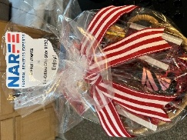
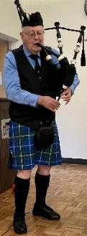
Next, a quick recap of recent events. The federation’s annual meeting was afternoon, October 1, Ellensburg, as a prelude to the Region IX Symposium, October 2 and 3. Both events were well organized, packed full of info, but there was time for meeting and/or reconnecting with NARFE members from across the 5-state region. At the memorial service, Charlie Caughlan, WSF service officer, provided time for reflection with his bagpipes, playing “Amazing Grace,” and “Flowers of the Forest.” Linda O’Donnell, Region IX Alzheimer’s coordinator, had 3 fundraisers for the NARFE Alzheimer’s Research Fund – resulting in $1,239 (with more than $70 from the Tri-Cities Chapter 1192 gift basket)! More details, including access to the presentations, at: www.narfe.org/region09/meetings.

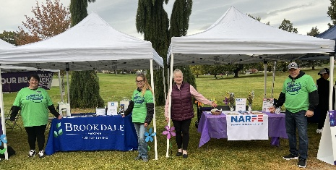
During September and October, the annual Walks to End Alzheimer’s. Spokane and Tri-Cities chapter members had a NARFE presence at their respective Walks. As DVP, I was able to represent NARFE and the federation at the Moses Lake, Wenatchee and Yakima Walks as there are no longer NARFE chapters there. Good networking! See pic, right, Yakima Walk, with members from a NARFE affinity partner, Brookdale. (Next year, hope to make the Quad Cities Walk – Lewiston, Clarkston, Moscow and Pullman areas.)
Public Relations – Mary Binder
Contact our Federal Legislators
The Honorable Dan Newhouse, 4th Congressional Dist.
U.S. House of Representatives
Phone: 202.225.5816: Fax: 202.225.3251
https://newhouse.house.gov
3100 George Washington Way, #130, Richland, WA 99354
Phone: 509.713.7374

The Honorable Patty Murray, U.S. Senate
Phone: 202.224.2621; Fax: 202.224.0238
https://murray.senate.gov
825 Jadwin Ave., Suite 160K, Richland WA 99352
Phone: 509.453.7462

The Honorable Maria Cantwell, U.S. Senate
Phone: 202.224.3441; Fax: 202.228.0514
https://cantwell.senate.gov
825 Jadwin Ave., Suite 206, Richland WA 99352
Phone: 509.946.8106; Fax: 509.946.6937

As I wrote in the last chapter newsletter, September, October and November are the chapter’s busiest “outreach” months! So, a recap and look ahead!
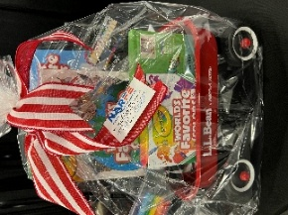
- September 17, the 31st Annual Senior Picnic, HAPO Center. Hundreds of attendees, a wide variety of vendors, good networking and conversations, lunch, music and prizes highlighted the event. Popular at the NARFE table – the red wagon gift basket!

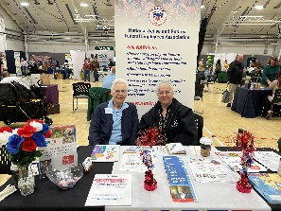
- October 13, the fall Senior Times Expo – more than 80 vendors and 725-plus attendees. Thank you, NARFE chapter helpers – Nancy Crosby, Janice Lake, Alicia Mercado, Nancy Pochert, John Wetterling. (Nancy, Alicia, pic, right)
- October 31, Yakima Valley Veterans Stand Down & Benefits Fair, 9 a.m. to 2 p.m., Sun Dome, State Fair Park, Yakima … as this newsletter goes to press, NARFE is registered to have a table, and staffed with NARFE volunteers from the Tri-Cities and Yakima. Thank you!
- November 6, Tri-Cities Veterans Resource Expo, 9 a.m. to 3 p.m., HAPO Center, Pasco. Yes, a NARFE table and help. Thank you, volunteers!
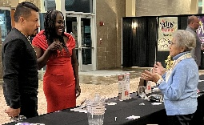
- November 14, coat check, Tri-Cities Wine Festival, Three Rivers Convention Center, Kennewick, 7 to 10 p.m. (Pic, right, w/member June Ollero, 2025) Donations go to the NARFE Alzheimer’s Research Fund. In advance, thank you volunteers!

Other Announcements:
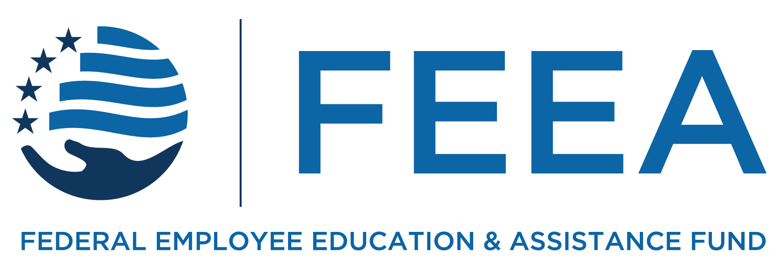
- The 2027 NARFE-FEEA scholarship program application period is expected to open in mid-to-latter November. The (tentative) application deadline is March 11, 2027, 11:59 p.m. High school seniors related to NARFE members, and planning to attend college in 2027, are eligible to apply. More information at: www.feea.org/our-programs/scholarships.
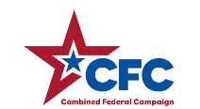
- The CFC is in a paused status. OPM decommissioned and took the online donation portal offline March 4.
- The November NARFE Magazine, page 59, has an updated schedule for the NARFE “open season” webinars. (These free-to-members webinars, follow-on Q&A sessions, other info are archived at: www.NARFE.org/webinars.
Legislative/NARFE-PAC – Mary Binder
Recent voting results for NARFE and Washington State Federation elections revealed the chapter exceeded the average number of voters by several points! So, I believe chapter members take voting seriously and have been or will be voting in the November 3 national, state and local elections, as this newsletter is finalized. Thank you to those able to honor the voting privilege we have.
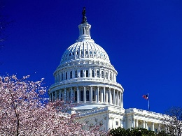
With expected changes in federal election results, I want to repeat information in the last newsletter regarding navigating through all this. The NARFE Magazine helps; but the most current legislative information is on the NARFE website, www.narfe.org, as it is updated weekly. Log into the website, then go to Advocacy and Bill Tracker. Currently, there are 6 bill categories and as of October 20, NARFE was monitoring 75 bills, including whether NARFE supports, does not support, or has no position on a bill. See page 15, November NARFE Magazine, for NARFE’s top priorities, and the October magazine for our elected officials’ voting records on NARFE’s key legislative priorities.


NARFE-PAC – the 7th quarter reports, for the 2025-2026 period that ended September 30, are now on the NARFE website. Again, our chapter, state and region strongly supported NARFE-PAC. Some highlights:
- Our Region IX again was 1st in mean average, $131.08 vs. the 10-region average of $100.36.
- Of the 50 states, DC and Puerto Rico, Washington state was: 4th in mean average; 5th in sustainers and amount given; and 7th in contributors. Wow!
- Of our 10 Washington chapters, we tied with Bremerton for 1st in sustainers, and were 5th in total given and contributors.
Thank you to all who have provided PAC support!
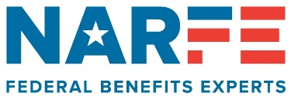

Return Service Requested

NARFE
Washington State Federation
Tri-Cities Chapter 1192
2802 W. 40th Avenue
Kennewick WA 99337-2666

2027 COLA Updates
NARFE website, www.narfe.org,
Education tab, then Up-to-Date COLA, TSP and More tab.


Treasurer – Liz Bowers
Our chapter finances have been very stable the past few months but I expect some changes between now
and the end of the year, primarily due to
fall being the busiest “outreach” season as President Mary Binder has reported. However, the federation’s 50-percent matching funds program provides some reimbursement for events and items identified in the chapter’s 2026 outreach plan!

Looking ahead, I expect the chapter’s 2027 budget to be close to this year’s. I’ll be discussing this with the chapter board at its December meeting. If you have budget questions and/or ideas, please contact me!

Membership Coordinator – Johanna Caylor
As of October 21, we had 440 members – 206/chapter;
234/national-only in the chapter area. This is a decrease of 2/chapter and 3/national-only members since my last report; but I recently received good news – no chapter member was dropped for failing to renew within the past 2 months and we have some prospective members!

Reminder! NARFE’s Fall Membership Drive ends
November 30! See page 68, November NARFE Magazine, for details, including recruiter rewards!

Dues Withholding: For retirees, consider this option! It helps avoid forgetting to renew your membership.

Membership Questions/Issues: Call or email me.
Ph: 509.375.0739; Email: annahojx2@gmail.com


Webmaster – Larry Williams
The chapter website is regularly updated when new info is received. Suggest members regularly checking it, too, at www.narfe1192.org!

Sunshine Coordinator – Faye Vlieger
(Cards sent since the September/October newsletter.)

TO:

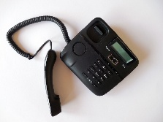
Caller Coordinator Updates
Our volunteer callers are still experiencing too many messages they leave with no return calls. So, another request to please return the calls –
whether to make a reservation or
let the caller know you cannot
attend.
Below is the list of callers and the
alpha letters they call based on a member’s last name:
(A-C) Nancy Crosby (J-M) Alicia Mercado
(D-F) Randy Grekowicz (N-R) John Wetterling
(G-I) Janice Lake (S-U) Nancy Crosby
(V-Z) Faye Vlieger
Questions? Need info? Want to be a caller?
Contact: John Wetterling; Phone: 509.948.9894
Email: wetterlingjohn@gmail.com

Passing: Condolences to Yvonne Plahuta on the passing of her husband/chapter member Maynard.
Thinking of you: Allison Wright and Gail Splett
Know someone needing some “sunshine?” Call or email me: 509.961.1095; einvlieger@aol.com.

Alzheimer’s Coordinator – Larry Williams
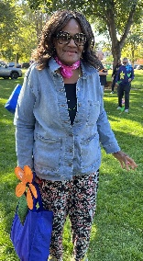
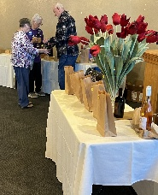
Two annual chapter fundraising events for the NARFE Alzheimer’s Research Fund. At the October chapter meeting – the “white elephant,” which raised $2,455! (Photo, left, Johanna Caylor receiving her “win” from Larry and Nancy Crosby)
Next, the area’s Walk to End Alzheimer’s, Howard Amon Park, October 10. We had a NARFE table and member volunteers. (Janice Lake, photo, right) Money raised, to date, $270. Team contributions until December 31. Thanks to all who helped, donated …!

